User Guide

EPO Interpreter Glossary Search Tool
This document provides instructions for the EPO Interpreter Glossary Search Tool.
The tool is designed to help you search quickly while also offering background information.
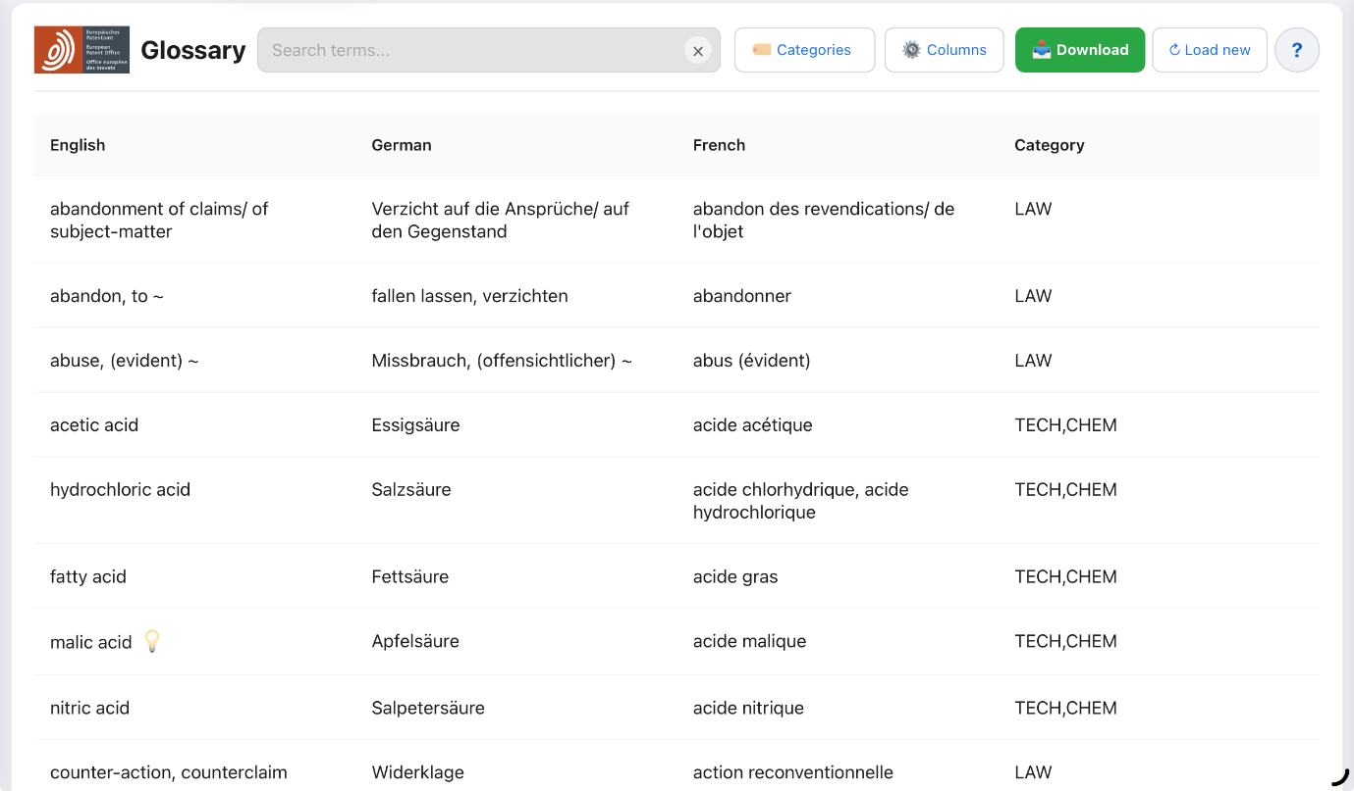

1. The Start Screen & Loading Glossary Data
Launching the app, you will see the Start Screen. Note that you will need an internet connection to access the website. Once the page has loaded, the tool should continue to work if your WiFi connection drops because the glossary is stored locally.
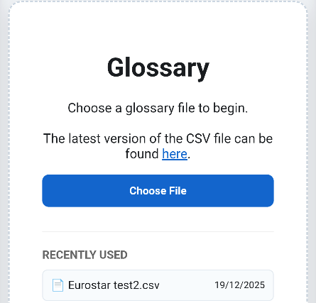
- How to load: Click "Choose File" and select your glossary file.

Recently Used Files
- To simplify things, in the "Recently Used" section, you will see a list of files you have previously opened. Simply tap a filename to reload that glossary immediately.

NB: CSV vs Excel - A boring but important distinction
The tool will not work with any old spreadsheet file.
It requires data in CSV (Comma Separated Values) format (specifically CSV UTF-8).
- The Difference: While Excel files (.xls or .xlsx) contain complex formatting, a CSV is a lightweight, high-performance format.
- Speed: The CSV format allows the tool to search through thousands of technical terms instantly without lag.
- Converting files: If your glossary is in Excel or Numbers, simply use "Save As" and select CSV (Comma-delimited) UTF-8 to convert the file to the correct format. You might have to click Advanced to ensure Numbers uses UTF-8 format.

2. Downloading the Latest Glossary
The official EPO terminology database is stored on Microsoft SharePoint, the same place you access documents for oral proceedings.
The Language Service will inform you periodically if there is an updated version available and provide you with the working glossary file.
However, if you do wish to check manually to ensure you have the latest data:
- Click here to go to MS Lists.
- In the top toolbar, click the Export button.
- Select Export to CSV.
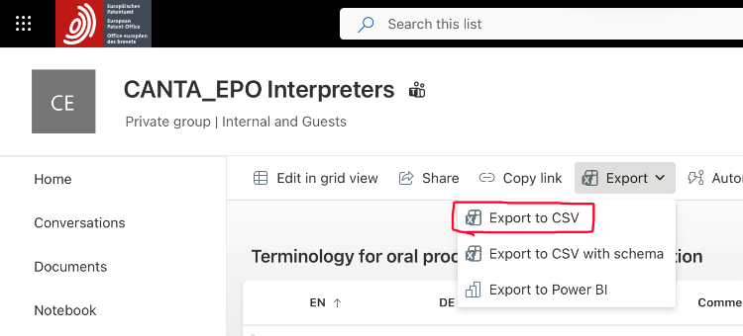
- Once saved to your device, click the Choose File button to load the glossary file.

3. The Search Tool Interface
The interface is designed for speed, allowing you to find terms quickly.

🔍 Instant Search
Type any part of a word into the search bar. The list filters instantly—there is no need to press "Enter."
Clearing the Search bar quickly to search again:
- Touch/Mouse: Tap or click the X icon at the right of the search bar.
- Windows: Press the Esc key.
- MacOS or iPad: Press ⌘ + . (Command and full stop) simultaneously.

🏷️ Categories
Filter results by legal or technical field. When filters are active, a blue counter appears. Click "Reset" next to the badge to clear these filters.

⚙️ Show/hide columns
Toggle the visibility of English, German, French or Category columns as required.

💡 Definitions
If a term displays a Light Bulb icon, it contains supplementary information, such as a definition, chemical formula or link.
- Opening: Click or tap anywhere on the row to open the details pane.
- URLs: Links within the details pane are active; clicking them will open the source in a new tab.
- Closing: click or tap X to close the side pane.
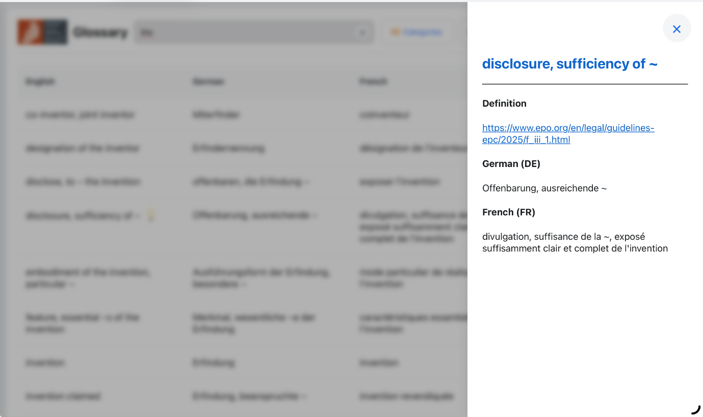

❔ Action buttons


- Download: Saves your currently filtered view as a new .CSV file which you can open in any spreadsheet app, such as Excel, Numbers, Google Sheets etc.
- Load New: Takes you back to the Start Screen to load a different glossary.
- Help (?): Opens the built-in quick-start guide.

4. Device Optimisation

Tablet: Landscape vs. Portrait
The tool detects your tablet's orientation automatically:
- Landscape: Displays a full tabular view for maximum context.
- Portrait: Optimises the header so the search bar remains large and easy to tap, while buttons are neatly arranged below it.
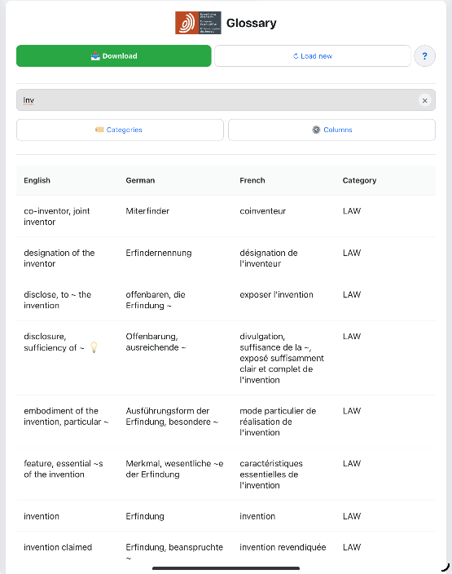

Mobile: Card View
On mobile phones, (or in Slide Over view on iPad) the tool switches to a more touch-friendly Card display. The details pane opens in full screen. Tap X to close.
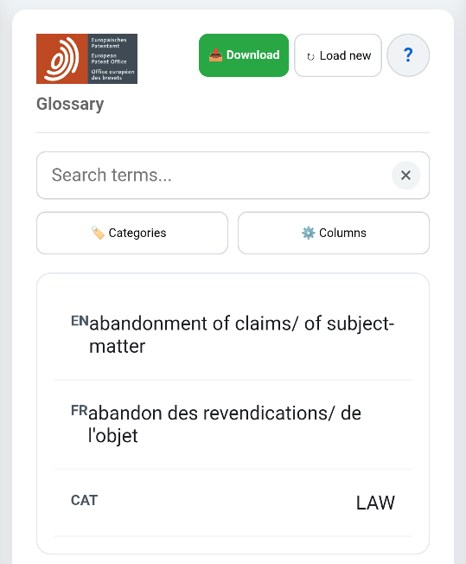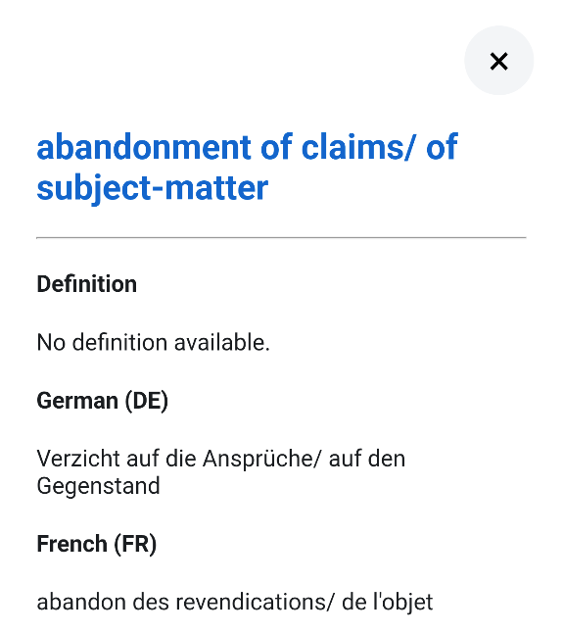

5. Installing as an App
Installing the tool as a "Web App" provides a full-screen experience and allows for quick launching from your device's Dock or Home Screen.

Mac OS (Safari)
- Open the tool in Safari.
- Go to the File menu in the top Apple menu bar.
- Choose Add to Dock.
- The application icon will now appear in your Dock for one-click access.

iPad & iPhone (Safari)
- Tap the Share icon ().
- Select Add to Home Screen, then tap Add.
- To add to the Dock: Go to your home screen. Find the EPO icon. Press and hold the new icon and drag it into the bottom Dock area of your iPad.

PC (Chrome or Microsoft Edge)
- Click the three dots menu on the top right (⋮), then click Cast, save and share, Install page as app.
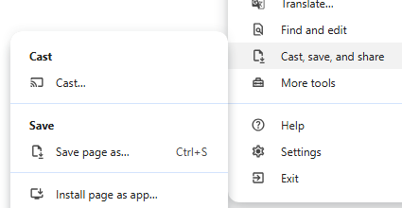).
- Click Install.
- Right-click the app icon in your Taskbar and select "Pin to Taskbar".

Android (Chrome)
- Tap the three dots (⋮) in the top right.
- Select Install app or Add to Home screen.

